

**MASINDE MULIRO UNIVERSITY OF SCIENCE AND TECHNOLOGY**

**FACULTY OF SCIENCE**

**DEPARTMENT OF COMPUTER SCIENCE**

**MMUST ONLINE-COURSE APPLICATION SYSTEM**

**A Project Report Submitted in partial fulfillment of the requirements for the award of the degree of Bachelor of Science in Computer Science of Masinde Muliro University of Science and Technology.**

**PRESENTED BY**

**KIPNGETICH HILLARY**

**COM/0005/12**

**PROJECT SUPERVISOR**

**MR. NAHASON MATOKE**

**DATE**

**27th October, 2015**

# Declaration and Certification

I *Kipngetich Hillary* – *COM/0005/12*, declare that this Project Report is my original work and has not been published and/or submitted for any other degree award in any other University before.

Signed: ……………………………. Date: ……………………………….

# Certification

The undersigned certify that they have supervised and coordinated and hereby recommend for acceptance of Masinde Muliro University of Science and Technology a project report entitled **“*MMUST Online-Course Application System”***

Signature…………………………… Date………………………………..

**Supervisor**: Mr. Matoke Nahason

Lecturer, Department of computer science

Masinde Muliro University of Science and Technology

Signed…………………………… Date……………………..

**Coordinator**: Mr. Kimanzi

Lecturer, Department of computer science

Masinde Muliro University of Science and Technology

## Dedication

I dedicate my project work to my family and many friends. A special feeling of gratitude to my loving parents, John and Alice Sigei whose words of encouragement and push for tenacity ring in my ears. My siblings Nicholas, Lilian, Damaris, Curren and Tabithah have never left my side and are very special.

I dedicate this work and give special thanks to my best and ever-helping friends Harrison, Seth, Wycliffe and Fredrick for being there for me throughout the entire period of my project.

## Acknowledgement

It is a great pleasure for me to acknowledge the assistance and contributions of all the people who helped me to make my project successful. My project would not have been so successful, without the dedicated assistance given by those individuals.

I would like to give my special thanks to Mr. Matoke (Project Supervisor) and Mr. Kimanzi (Project

Coordinators) for the advises and experience they shared with me throughout the project period. I would also like to thank my colleagues and all other Officials of Department of Computer Science for the assistance and guidance they gave towards this project.

I would not forget my roommate Harrison Kanda (com/00012/12) for the support and cooperation he had at all times. Finally I would like to thank every individual (who I have not mentioned names above) who gave me even the slightest support (even by words) to make my project successful. *Thank you every one!!*

## Abstract

Masinde Muliro University of science and technology is one of the oldest public universities in Kenya. It offers variety of courses ranging from certificate to phd. The system is aimed at assisting the applicants, specifically certificate, diploma and degree applicants who in most cases are faced with financial challenges of downloading the application forms, filling it then sending it back to the campus for

consideration. The system will make the application easier since the applicants just have to create accounts or rather register then make the application after which they wait for the application status. The status will be available in their accounts once their applications have been processed. Applicants can as well view announcements on various matters; they can make inquiries after which the admin at the back end responds to them.

The system will help to alleviate corruption and any other unjust act in the course of applicants vetting since the system itself will do the vetting based on the applicant’s academic qualifications and the number of applicants required by the department.

The system will also reduce inconveniences where applicants fail to get application results in time where in most cases have been forced to travel to campus in person to confirm the status of their applications. Such unplanned expenses will be reduced by the system.

The system will be developed using HTML5 for user interface design, JavaScript libraries for client-side validation, bootstrap framework for look and feel of the user interface, JSP for server side scripting and MySQL database technologies.

## Executive Summary

This paper highlights the various sections of the project undertaken. The introduction gives an overview of the subject of the project, why the project was chosen, and the main goals of the project. After the introduction, background information will try to explain what necessitated the research and show how technology has been embraced in the current business world.

In the problem definition, the paper explains how the current system works and the various procedures used to carry out various functions of the current system. Thereafter, project justification section explains how the project intends to automate the current system and also justify the desirability of the new system.

Under Methodology, the paper describe the procedure that was followed during the system development, the tasks undertaken in order to achieve the objectives of the project and also identify the data needed and how it was collected. It also covers the full system analysis and design and test cases.

In the implementation and testing section, this paper explains the coding scheme implemented while developing the project, the various levels of testing performed on the system and the various test cases undertaken.

The paper will also mention under system requirements the various resources and equipment that were to develop the system and also an estimate of the cost incurred in the process.

The paper then gives the schedule that was followed during system development process in the form of a Gant chart. Finally, the conclusion emphasizes on the benefits the users will get by using the system developed

## Table of Contents

Declaration ..................................................................................................................................................... i Dedication ..................................................................................................................................................... ii

Acknowledgement ....................................................................................................................................... iii

Abstract ........................................................................................................................................................ iv Executive Summary ....................................................................................................................................... v

1.0 CHAPTER 1......................................................................................................................................... [1]

1.1 Introduction ...................................................................................................................................... [2]

1.2 Choice of Project ................................................................................................................................ [3]

1.3 Functional Goal .................................................................................................................................. [4][5][6][7][8][9][10]

1.4 Background of Study .......................................................................................................................... [11]

1.5 Problem Definition ............................................................................................................................ [12]

1.6 Feasibility Study ................................................................................................................................. [13]

1.6.1 Economic Feasibility .......................................................................................................................... [14]

1.6.2 Technical Feasibility .......................................................................................................................... [15]

1.7 Requirement Capture and Analysis .................................................................................................. [16]

3.4 Architectural Design ........................................................................................................................ 10

3.5 Database Design .............................................................................................................................. 13

3.6 Interface Design .............................................................................................................................. 13

3.7 Component Design .......................................................................................................................... 14

3.7.1 Registration Module ....................................................................................................................... 14

3.7.2 Login Module .................................................................................................................................. 15

3.7.3 Applicant Module ............................................................................................................................ 15

3.7.3.1 Homepage ....................................................................................................................................... 15

3.7.3.2 Course Application .......................................................................................................................... 16

3.7.3.3 Announcements .............................................................................................................................. 17

3.7.3.4 Details ............................................................................................................................................. 18

3.7.3.5 Inquiries .......................................................................................................................................... 18

3.7.3.6 Application Status ........................................................................................................................... 19

3.7.4 Administrator Module .................................................................................................................... 20

3.7.4.1 Homepage ....................................................................................................................................... 20

3.7.4.2 View Applicants ............................................................................................................................... 20

3.7.4.3 Post Announcements ...................................................................................................................... 21

3.7.4.4 Applicants Ranking .......................................................................................................................... 22

3.7.4.5 Inquiries .......................................................................................................................................... 23

4.0 CHAPTER 4....................................................................................................................................... 24

4.1 Implementation and Testing ........................................................................................................... 24

4.2 Coding ............................................................................................................................................. 24

4.3 Unit Testing ..................................................................................................................................... 25

4.4 Module Integration and Testing ..................................................................................................... 25

4.5 Validation Testing ........................................................................................................................... 25

4.5.1 Test Cases ........................................................................................................................................ 25

4.5.1.1 Test Case 1 ...................................................................................................................................... 25

4.5.1.2 Test Case 2 ...................................................................................................................................... 27

4.5.1.3 Test Case 3 ...................................................................................................................................... 28

4.5.1.4 Test Case 4 ...................................................................................................................................... 32

4.6 Configuration Review ...................................................................................................................... 34

4.7 Security Testing ............................................................................................................................... 34

4.8 Actual Handover ............................................................................................................................. 34

5.0 CHAPTER 5....................................................................................................................................... 35

5.1 Summary and Achievements .......................................................................................................... 35

5.2 Constraints ...................................................................................................................................... 35

5.3 Shortcomings .................................................................................................................................. 35

5.4 Discussion ........................................................................................................................................ 36

5.5 Conclusion ....................................................................................................................................... 36

5.6 Recommendations .......................................................................................................................... 36

5.7 Appendix ......................................................................................................................................... 37

5.7.1 Project Schedule ............................................................................................................................. 37

5.7.2 Budget ............................................................................................................................................. 38

5.8 References ...................................................................................................................................... 38

### FIGURES

**Figure 1:** General interaction between web server, JSP engine and Clients…………………………………………**9**

**Figure 2:** Architectural design of the system and communication flow between components **…………12**

**Figure 3:** Enhanced Entity-Relationship (EER) model for database entities…………………………………………**13**

**Figure 4:** Screen Shot of User Registration page…………………………………………………………………………………**14**

**Figure 5:** Screen Shot of User Account Login page………………………………………………………………………………**15**

**Figure 6:** Screen Shot of Applicant’s Homepage…………………………………………………………………………………**16** **Figure 7:** Screen Shot of Course Application page………………………………………………………………………………**17**

**Figure 8:** Screen Shot of Applicants’ Announcements area…………………………………………………………………**17** **Figure 9:** Screen Shot of Applicants’ Details page……………………………………………………………………………….**18**

**Figure 10:** Screen Shot of Applicants’ inquiry area………………………………………………………………………………**19**

**Figure 11:** Screen Shot of Application Status dialog…………………………………………………………………………….**19**

**Figure 12:** Screen Shot of Admin Homepage……………………………………………………………………………………….**20**

**Figure 13:** Screen Shot of Degree Applicants……………………………………………………………………………………….**21**

**Figure 14:** Screen Shot of Announcement posting modal…………………………………………………………………….**21** **Figure 15:** Screen Shot of Degree Applicants Ranking………………………………………………………………………….**22**

**Figure 16:** Screen Shot of Admin’s Inquiry area……………………………………………………………………………………**23**

#### Figure 17: User Registration…………………………………………………………………………………………………………….26

**Figure 18:** Successful Temporary Registration before account activation…………………………………………….**26**

**Figure 19:** Login Entry Point…………………………………………………………………………………………………………………**27**

**Figure 20:** Unsuccessful Login Feedback………………………………………………………………………………………………**28**

**Figure 21(a):** Personal details entry…………………………………………………………………………………………………….**29**

**Figure 21(b):** successful submission of personal details………………………………………………………………………**29**

**Figure 22(a):** Education background details entry**…………………………………………………………………………….30**

**Figure 22(b):** successful submission of academic details……………………………………………………………………..**30**

**Figure 23(a):** Course details entry**…………………………………………………………………………………………………….31**

**Figure 23(b):** Successful submission of course details**……………………………………………………………………….31**

**Figure 24:** Form print**……………………………………………………………………………………………………………………….32**

**Figure 25(a):** Screen Shot of Diploma Ranking**………………………………………………………………………………….33**

**Figure 25(b):** Successful Diploma Ranking**…………………………………………………………………………………………33**

### TABLES

**Table 1:** Project Schedule from week 1 to week 15……………………………………………………………………………..**37**

**Table 2:** Project Budget**……………………………………………………………………………………………………………………38**

# 1.0 CHAPTER 1

## 1.1 Introduction

An Information System is an organized portfolio for obtaining, processing and delivering information in support of business operations and management of an organization (NIIT, 2004). Computer Based Information System (CBIS) utilize computers and telecommunications technology in the capture, processing, storage, manipulation, and dissemination of information. CBIS are essential in modern business environments because they help people analyze problems, visualize complex subjects, create new products, communicate, and make decisions, co-ordinate, and control work activities. Components of CBIS are Technology, Organizations and Management.

Since the start of Masinde Muliro University, it has been using the unreliable method of course application process which has proved inefficient and inconvenient especially to the applicants. Applicants are still supposed to visit university website, download the application form, fill the forms then send them back to the University for processing. This method poses a lot of challenges especially on the delivery of the forms back to the university and communication of application results.

Implementation of an information system can help alleviate such problems. Mmust online-course application system is designed to help this Institution address these challenges. With this system, an applicant is able to make an application online then wait for the feedback from his/her place of comfort without the hustle of forwarding the filled application form to the university which might in some cases delays.

The system will be integrated into the mmust website and can then be accessed online from anywhere provided there is internet connectivity. The admin in charge should be able to activate the link to the system when the application is on and deactivate it when the application is due.

## 1.2 Choice of Project

To develop a project that will ease the entire process of course application in the university without having to post the application forms on line for downloads by the applicants.

## 1.3 Functional Goal

To develop a system that will allow the applicants to easily apply for a course of their choice from their places of comfort, reduce if not to eliminate unnecessary costs incurred by the applicants in the process of applying for courses, and also eliminate the manual tasks associated with processing the applications by the concerned university body.

## 1.4 Background of Study

In the present world, every institution is trying to integrate Information technology in its core operations in the quest to remain relevant and also to maintain a competitive edge.

All sections in institutions, business sectors are emulating the growth and use of the technology as it advances day in day out. As a University of Science and Technology, MMUST should ensure that all of its day to day operations are automated so as to act as a lead example to other institutions especially in technology and also to take competitive advantage. Unfortunately, MMUST is still using the old way of course application which according to my research is tedious and unreliable.

Implementation of an online course application system will do great things in the University, it will revolutionize the whole process of course application to better, easy-to-do and enjoyable process. Applicants will be able to register or rather create their accounts then apply for courses of their choice then wait for application feedback which will be made available at their accounts once the applications have been processed. Only successful applicants will be requested to report to the university alongside their documents.

## 1.5 Problem Definition

Due to the increased thirst for university education by many Kenyans, there have been an increased number of the students who are applying for the university courses. Most of these applicants are those who missed regular admission by KUCCPS while some are those who just want to graduate as fast as possible. This is begged on the fact that students who joined university on regular basis in most cases take lengthy time to complete as compared to the self-sponsored students who in most cases do not go for long holidays.

Based on the research which I did by approaching my fellow colleagues who are self-sponsored, most of them are not contented with the current system or rather the current mode of application. Among the challenges they say are exhibited by the current system are as follows;

* The system is costly as it requires one to download the form, fill it then send it to the university. Most of the applicants are obliged to bring the forms themselves to the university due to lack of reliable means for sending the same.
* The system is not reliable. Most of the colleagues I approached said that the feedback mechanism is not reliable. One’s application can be successful but getting the feedback on the same sometimes is not guaranteed. Sometimes, the feedback comes but gets to the concern late after the reporting dates. To avert such incidences, most of the applicants have been coming to the university physically to make confirmation, which is very costly especially to those coming far away from the university.
* Some also complained that response to inquiries is never guaranteed. Some applicants do make inquiries via the given email but according to my research, most of these inquiries went unanswered.
* I also came to realize that most of them are not happy with the lots of details being asked to provide in the current application form.
* The concern body in the university also finds it difficult to arrange forms, go through them and make their consideration. In this way, they take a lot of time to complete the process. This becomes so tedious work for employees.

## 1.6 Feasibility Study

In order to ascertain the viability of the project, a preliminary study was undertaken amongst the users which entail: PSSP students, colleague students, staff members from registrar office.

### 1.6.1 Economic Feasibility

This was carried out to compare the cost of developing, operating and maintaining the proposed system and if it is economically viable in relation to return on investment. This served as my cost benefit analysis portion. The concern here was:

* How beneficial is the existing system or mode of operation?
* What are the costs associated with the existing system?
* What are the benefits of the proposed new system?
* What are the costs associated with the proposed system?

### 1.6.2 Technical Feasibility

This was carried out to make sure that there a technical capacity to carry out and implement the proposed system taking into account the current technical capacity of the university. The concern here was:

* Are there enough technological resources to undertake the project?
* Are the processes and procedures conducive to project success?

## 1.7 Requirement Capture and Analysis

Having established that the project was worth starting, a detailed description of the functionalities that the system was supposed to accomplish was done. These requirements were then explored to find out the needs or conditions to be met by the new system. Conflicting requirements were then eliminated.

The following activities were undertaken during this process:

* **Eliciting requirements***-*Intensive research over the Internet as well as brain storming with users and staff was done.
* **Requirements analysis and validation**-The requirements that were cited during the study was then analyzed to check for clarity, incompleteness, ambiguity and also

contradictions amongst them.

* **Recording the requirements***-*The requirements obtained was then documented using a natural language.

## 1.8 Purpose of the Project

The purpose of the project is to develop a working system that will ensure that the course application process in mmust is efficient and applicants are selected fairly only based on their academic qualifications.

## 1.9 Objectives of the Project

* To review the existing course application system.
* To develop an online application system that will help applicants to apply courses more efficiently.
* To eliminate unnecessary costs incurred by applicants during the application process.
* To hasten the application process and ensure that applicants are selected only based on merits.

## 1.10 Project Justification

Due to the mentioned challenges of the current system, I found it necessary and wanting to come up with an alternative system which tries to solve the stated challenges and make application process smooth and enjoyable. The focus of my project is department of computer science, certificate, diploma and degree programmes since most of these applicants are young Kenyans who have just completed high school and have not had any means of generating income to assist them overcome the costly nature of the current system.

The proposed system will try to address the stated challenges of the current system in the following ways;

* There will be no hustle of sending the application form to the university hence transport cost is reduced. Applicants are only supposed to apply for the course the print a pdf of the application which is to be presented at the university on the day of reporting together with other supporting documents.
* Feedback on the application status is guaranteed and much reliable. Applicants’ accounts will include an application status area where the results of the application is posted once application has ended and vetting done. Applicants will therefore be in a position to know if their application was successful or not via a button click.
* Inquiries will be made easier. Applicants can make inquiries from the inquiries area in their accounts which will be responded to by the admin concern. The inquiries area is very interactive and resembles a messaging tool.
* It will save time needed for consideration and vetting of the applicants thus expediting the process. The concern admin will be in a position to do the vetting by just specifying the number of applicants required per course.
* The system will be fair since applicants are considered only based on the academic merits.
* The application form will only require basic information.
* The concern management body will find it easy for application consideration since forms will be organized well in their database.

## 1.11 Requirements Specification

These involve:

* Functional requirements – statements of services the system should provide or is expected to provide.
* Non-functional requirements- constraints on the services or functions offered by the system.

### 1.11.1 Functional Requirements

MMUST online-course application system provides the following services; • Register applicants.

* Enable the applicants to apply courses of their choice from their accounts.
* Enable applicants to make changes on their application details.
* Enable applicants to make inquiries and get responses from their accounts.
* Enable applicants to see various announcements concerning their applications.
* Provide applicants with application status once the applications have been processed.
* The admin of the system should be able to close and open applications.
* Enable the admin of the system to respond to inquiries from applicants.
* The admin should be able to post and delete announcements.
* The admin should be able to view applicants in various categories.
* The admin should be able to rank applicants in various categories and also undo previous ranking where necessary.

### 1.11.2 Non Functional Requirements

* ***Robustness:*** the system is able to handle error conditions gracefully without failure e.g. invalid data defects and unexpected conditions
* ***Usability:*** The system can be easily used by any computer literate person.
* ***Maintainability:*** The system is easily maintainable as it is not extremely complicated and comes with a help function.
* ***Flexibility:*** The system is flexible and can be modified to suit the changing user’s needs over time.

#### • Others include;

* The system only presents an applicant with courses on which he/ she qualifies for.
* While applying a course, the system must be able to notify the user of the wrong inputs and give suggestive solution.
* The system shall also notify users on successful execution of a query or updates ➢ The system have an online help that assist users on how to operate the system ➢ User’s authentication shall be via valid username and password.

## 1.12 Materials Required

### 1.12.1 Software Requirement

* Linux Operating System (Ubuntu 14.04 LTS and above) or Windows XP Professional SP3 operating system and above
* Java SE Development Kit (JDK)
* Java Runtime Environment (JRE)
* Glassfish server 4.1
* Netbeans version 7.1.2 and above
* Servlet container (apache tomcat).
* Xampp 5.1.6
* MySQL dbms
* A web browser e.g. *Internet explorer, Mozilla Firefox, Google chrome or Opera mini.*

### 1.12.2 Hardware Requirement

* Pentium IV computers and other higher platforms. Minimum processor speed of 1.5 GHZ, 512MB of RAM and at least 40 GB of disk space.
* Standard peripheral devices of a personal computer system.

### 1.12.3 Others

* An external storage device of at least 1gb
* Wireless/wired Internet connectivity

# 2.0 CHAPTER 2

## 2.1 Literature Review

According to Aquino (2005), importance of computer application is increasing day by day. In the latest decades of the Millennium, winning organization are those which are willing to integrate business strategy and computer information technology in plying their respective trades. The use of computer information technology results for them to be able to develop products fast and make decisions fast, ability to have fluid organization structures, able to cope with the demanding work force and external environment by the rapid development of innovative approaches and lastly using information system confirms the company’s mission and vision. Learning institutions use information systems for instance in the way of implementing an enrolment system. This results for them to attract enrolees and earn an income. Enrollees are attracted because the use of the said system makes the transactions faster and easier.

“Lack of enrolment system in schools can lead to chaos and troubles”, as stated by Ace Adrian (2011). Students will be confused on what they should do to be able to enroll. That is why such systems is extremely useful in the way that it gives an ease on working on enrolment processes. Enrollment is very useful in retrieving vital information of the students. Without it can lead to difficulty both for the administration of school and student in enrollment processes.

Many countries nowadays, especially the developing nations are challenged by the rapid technological changes. This has radically changed the living and working styles of the entire society. This transformation has been driven partly by rapid technological innovation. While in the 20th century saw the rise of the industrial revolution with steam-powered machines intensifying and expanding human productive power, the 21thcentury was characterized by the birth of machine-powered flight and the emergence of broadcasting and computer technologies which extend the reach of human creativity even more and made possible new ways by which humans could live and work together (Tinio, 2002). The transformation of manual enrollment transaction to automate and now into web based automation is one example of what has driven partly by the rapid technological innovation. Any ways just to make work easier and faster like enrollment transactions is possible with the emergence of computer technologies. Technology innovation had influenced man’s work from data processing, business transaction, research, planning, monitoring and even in medical.

Web applications are popular due to ubiquity of its applications. The ability to update and maintain web applications without distributing and installing software on potentially thousands of client computers are key reasons for its popularity. A significant advantage of building web applications to support a standard browser feature is the ability to perform as specified, regardless of the operating system installed on a given client (Bacala&Reanno, 2009).

Mmust online-course application system is a web-based information system. A web-based course application system has features that meet most of academic institutions system’s needs and requirements. This includes standardized modules for student registration, course application, applicant ranking, and other modules that are deemed necessary to operate a course application process successfully. According to Jennifer Rowley (2005), information systems are a tool to support information management. Information systems are increasingly being used in organizations with the objective of providing competitive advantage. The information systems used by organizations can be grouped into different types such as transaction processing system, management information system, decision support system, executive information system, expert systems and office information system. Information Technology has heralded the advent of the information society. The information society may be a ‘virtual society’. The concepts of the electronic classroom, the electronic office and electronic library have been explored. Information system poses a number of issues on society in general, including: changing employment patterns, archiving, and bibliographic control, security and data protection, intellectual property, marketplace issues and access. A course application system serves as a tool to support information management with regards to the applicants’ data, their academic information and other with a connection to the application process. Every learning institution gain competitive advantage of having this system for they will have the capacity on admitting its students at ease and with security.

Online-course application system if implemented will make a huge impact into the institution arena. It is a system that is built on innovative program strategies. It is a system that will help both the enrollment personnel-in-charge and the students to easily process the application at a lesser time. Distinct from traditional application system, online-application system process large assortment of student records and provides efficient and consistent information services. As stated by Holmes (2006), “The Internet is neither an extraordinary communication tool nor revolutionary. It simply represents the current stage in the development of human capabilities through written language, which itself derived from the spoken form.” That statement only shows that advancement in modern technology is at their highest peak. Nowadays, Web-based applications are widely used due to their ubiquity. Web-based enrollment system is currently emerging on markets for they are offering transaction convenience and service efficiency through the use of Internet. This system becomes a powerful tool in dealing with information management regarding enrollment transactions.

While Masinde Muliro University of Science and Technology (MMUST) has made tremendous steps in automating most of its operations through the implementation of abno ERP, course application is still a stalemate in the sense that the ERP has not address the application process.

The mmust online-course application system is two-tier client/server architecture with a thin client:

* Presentation logic at the client side.
* Business and data management at the server side.

# 3.0 CHAPTER 3

## 3.1 Design and Methodology

## 3.2 General Overview

System design is an integral part in any working software worth implementing. In this section we shall look into the data aspect and component interface for ‘Mmust online-course application system’.

The system will generally interact with various entities from database server to Web server and will also interact with users via Web clients. This is as shown below.

Figure 1: General interaction between web server, JSP engine and Clients.



Internet



Web server



Clients



JSP servlet

engine



Database

The system has two ends;

**System backend*:*** The back end of the system consists of the JSP server side language, MYSQL database and XAMPP server. MYSQL is used as a storage media for data and processed information. The user is not aware of this as he/she just interacts with the interface provided for them in the front end.

**System front end:**This is the interface part of the system. All data entries are captured here. Bootstrap framework, JavaScript and jQuery have been utilized.

There levels that were applied in development of the system are;

* Design Methodology
* Architectural design
* Database design
* Interface Design
* Component design

## 3.3 Design Methodology

The entire development procedure for this system was based on v-shaped model of software development. The V-model is software development life cycle model where execution of processes happens in a sequential manner in V-shape. Each phase must be completed before the next phase begins.

The system was broken down into modules and subtasks. During the development process, the system went through the phases of feasibility study, requirements elicitation, requirements analysis, design, coding, verification and validation and implementation and support. V-shaped model carries several advantages

* It is a simple and easy model to use
* Each phase would have specific deliverables.
* It has a high chance of success due to the development test plans.
* This model works well for small projects
* Easy to manage due to the rigidity of the model. Each phase has specific deliverables and a review process.

## 3.4 Architectural Design

In this design level, the basic structural framework that identifies the major components of a system and the communications between these components. Below is a general model for the whole system; **Scenario**

### System Administrator

* Register as a user
* Login to the system
* post announcements
* reply to inquiries
* view applicants and delete where necessary
* rank applicants

### Applicant

* Register as a user
* login to the systematic
* apply course(s)
* view announcements
* make inquiries
* edit details
* view application status

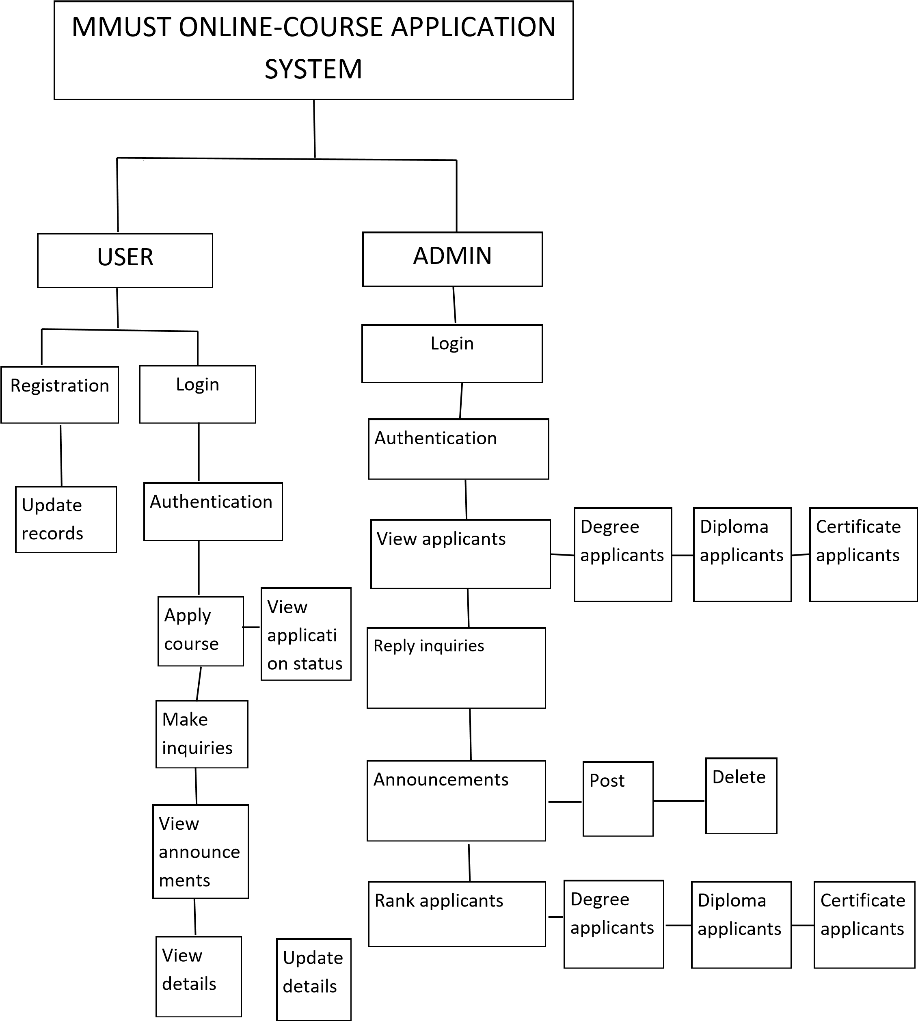

Figure 2: Architectural design of the system and communication flow between components.

## 3.5 Database Design

This involves the design structure of the database. This design has not yet been done in my system.

However, ER model will be used to show the relationship between the various entities in the system.

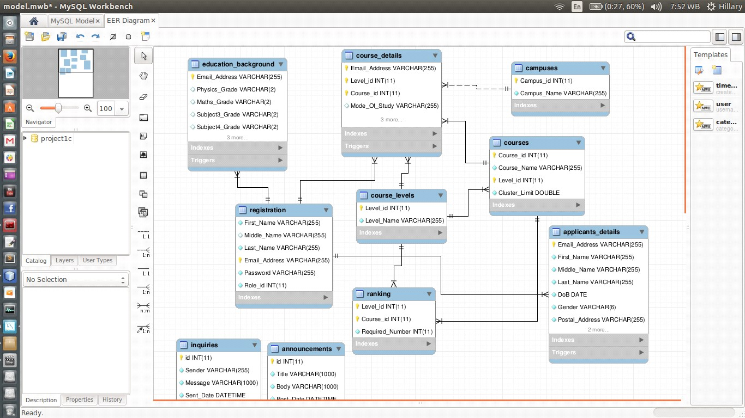

Figure 3: Enhanced Entity-Relationship (EER) model for database entities.

## 3.6 Interface Design

In designing the systems’ interface, I attempted to emulate Jacob Nielsen’s usability heuristics as described below:

### User control

The interface has been made to adapt to the needs of the user. I provided more than on way of doing same task. This is made possible by provision different links located at different parts for doing the same task

### Match between system and real world

The web-page module was designed to emulate/resemble the normal requirements of guests **Consistency**

Consistency is about making similar things look and behave similar. The front end and the back end of my system are consistent. This provides users with a good chance to learn new contexts (and to detect new contexts), to concentrate on relevant tasks, to feel safe.

**Minimalistic design**

In each form, only information that is directly relevant to the task in hand is displayed.

### Error recognition and diagnosis

While using the system a user can tell when an error has occurred as error messages are displayed and possible ways to get out of the error are suggested.

## 3.7 Component Design

This is the structural design of various modules in the system.

### 3.7.1 Registration Module

This is where new users of the system get registered. Upon submission of successfully entered details, an account activation link is sent to the email provided where the user is supposed to activate their account before logging into the system. Successful activation of the account fully registers the user with the system.

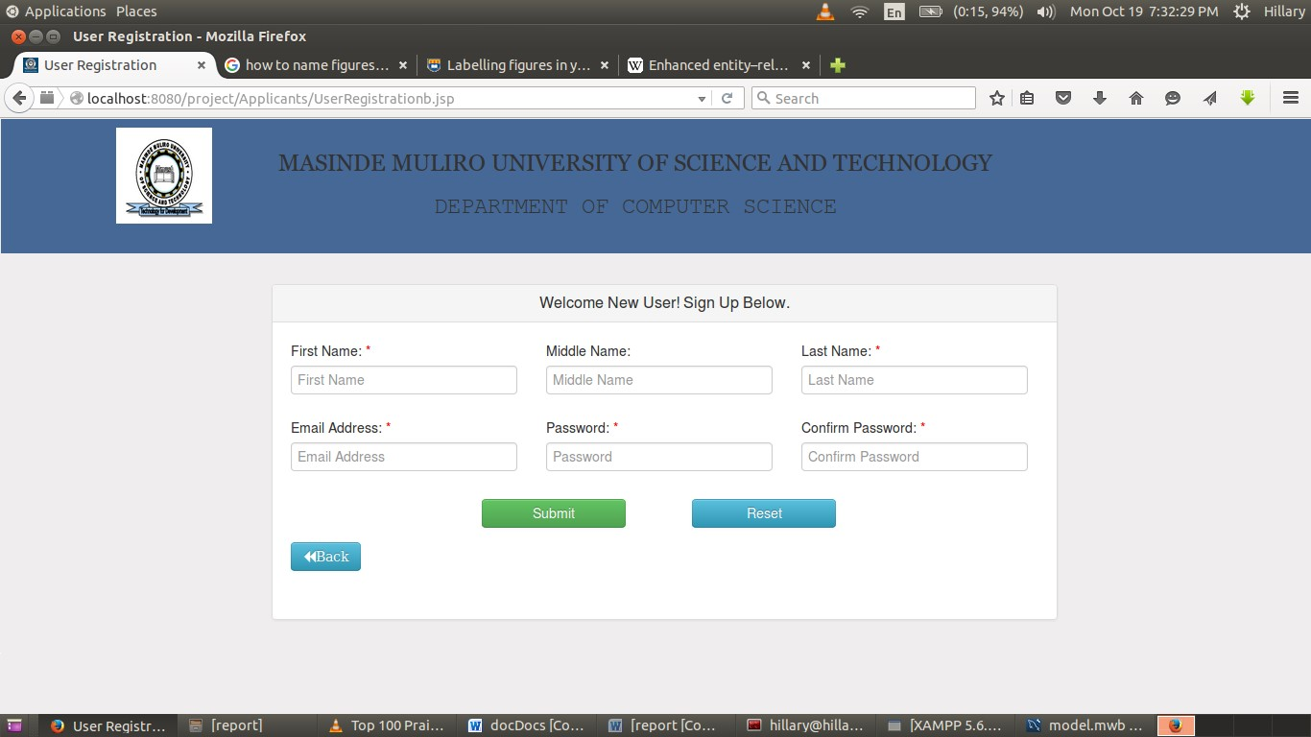

Figure 4: Screen Shot of User Registration page

### 3.7.2 Login Module

This screen shot shows an entry point from where users (administrators and Applicants) get access to the system. Users use valid emails and password to login.

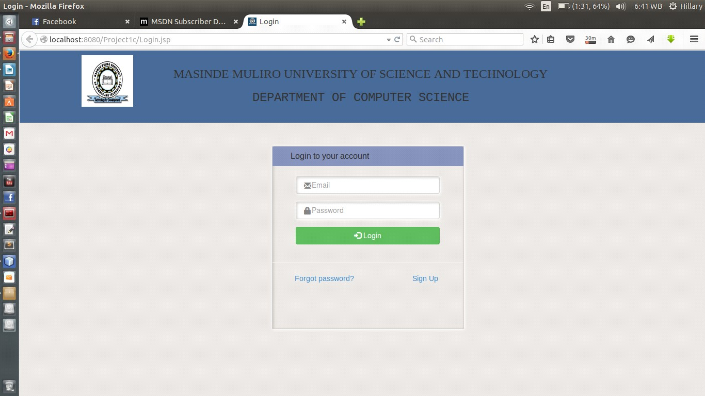

Figure 5: Screen Shot of User Account Login page

After users have successfully logged in, they are directed to their specific main page depending on user category from where they can choose various options to perform the various activities that are provided by the system.

### 3.7.3 Applicant Module

This is one of the main modules of the system. It encompasses all the units that enable the applicant to accomplish his/ her tasks. It has the following sub-modules:

#### 3.7.3.1 Homepage

This page apart from being the applicant’s dashboard also saves as a help area where the applicant is given guidelines on how to apply for a course. It also informs on whether the applications are still opened or closed.

Figure 6: Screen Shot of Applicant’s Homepage

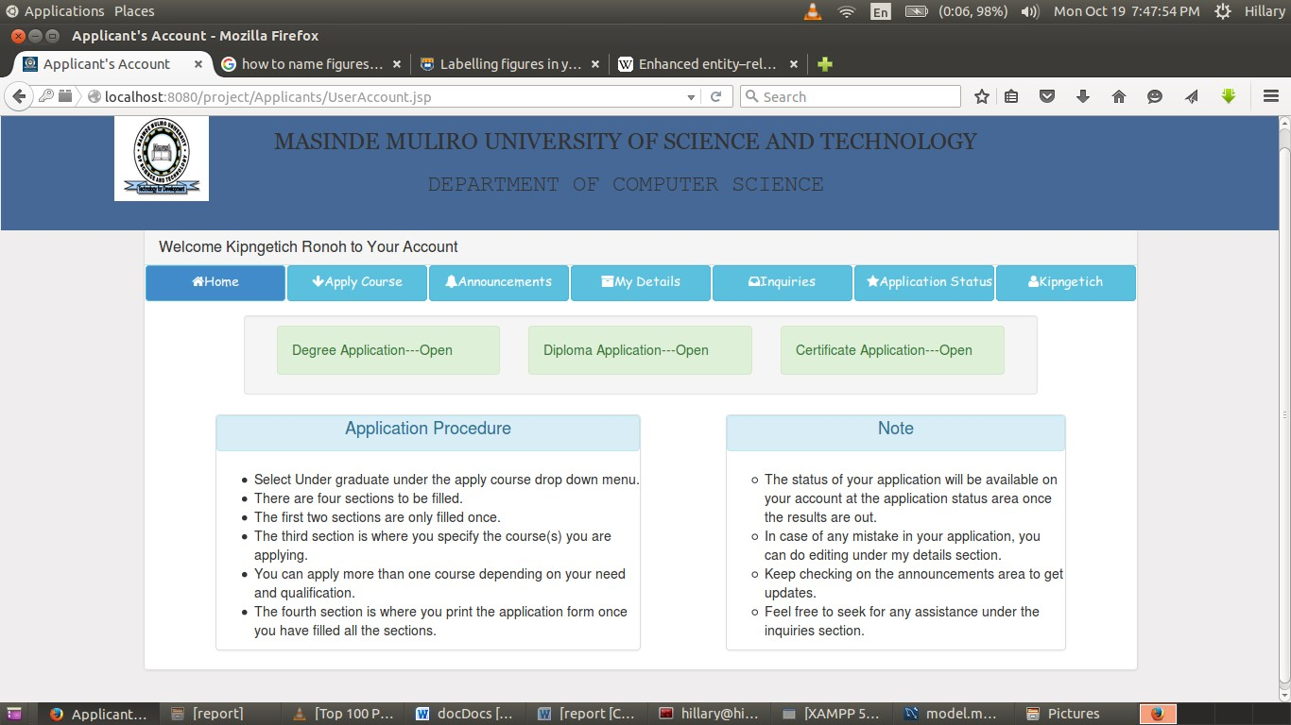

#### 3.7.3.2 Course Application

This is where the applicants do the actual course application. It has four sections namely:

* SECTION A: Personal Details
* SECTION B: Education Background
* SECTION C: Course Details
* SECTION D: Print Form

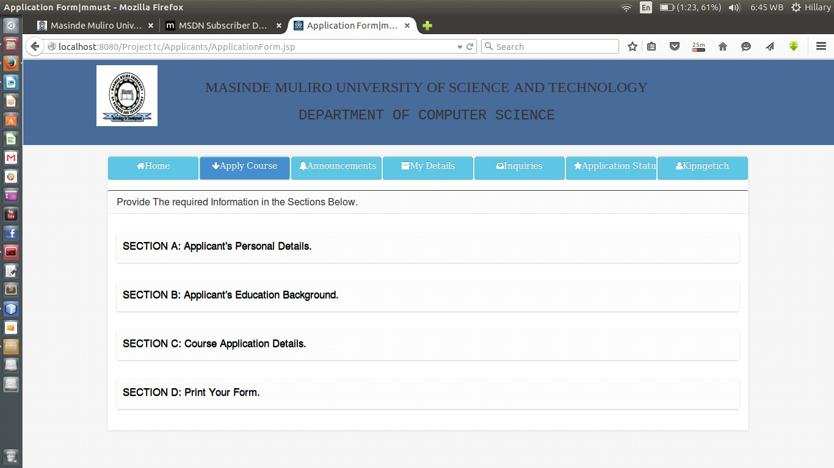

Figure 7: Screen Shot of Course Application page

#### 3.7.3.3 Announcements

Announcements posted by the admin of the system on various issues are displayed here.

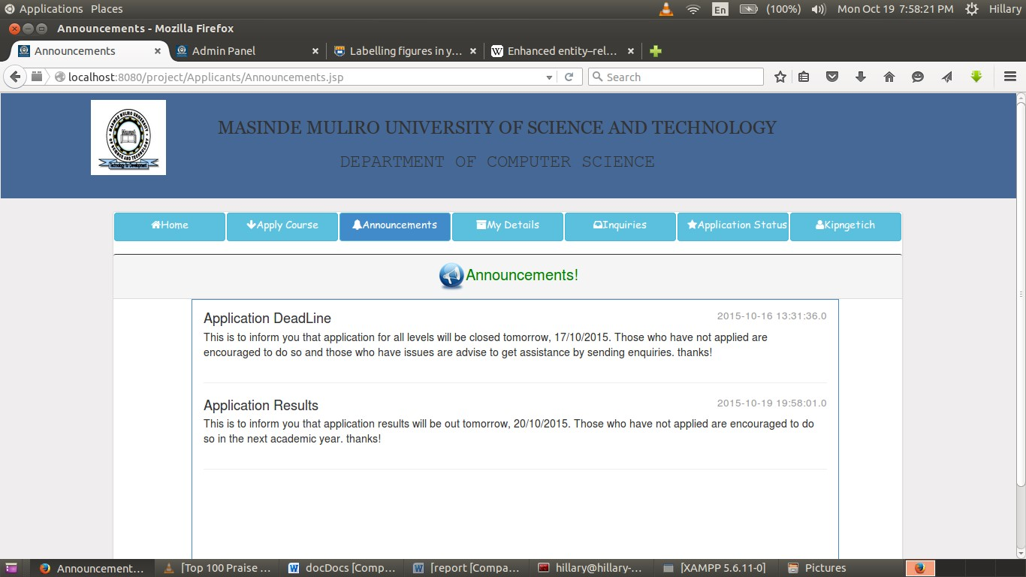

Figure 8: Screen Shot of Applicants’ Announcements area

#### 3.7.3.4 Details

This is where the applicants can view his/her details and edit where necessary. However, the editing option is only active when applications are still open.

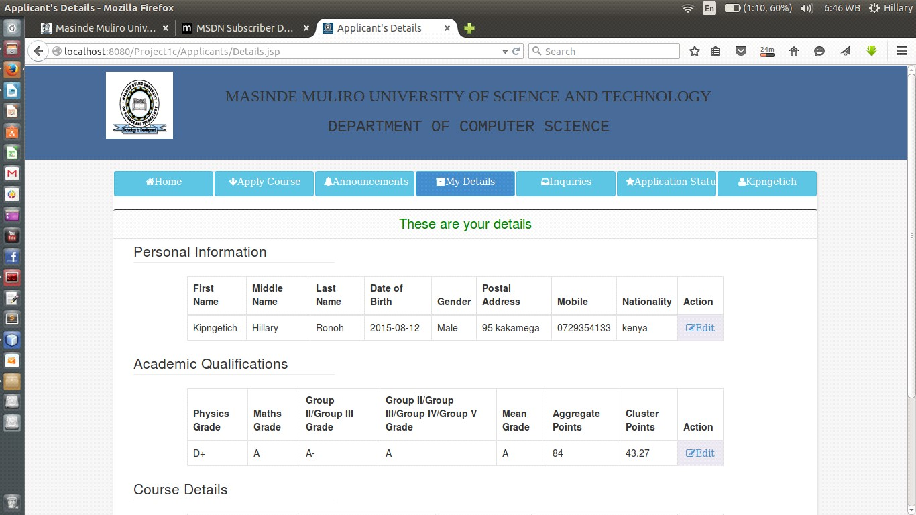

Figure 9: Screen Shot of Applicants’ Details page

#### 3.7.3.5 Inquiries

This module enables the applicant to have a one-to-one chat with the admin of the system. The applicant can make any inquiry from this page.

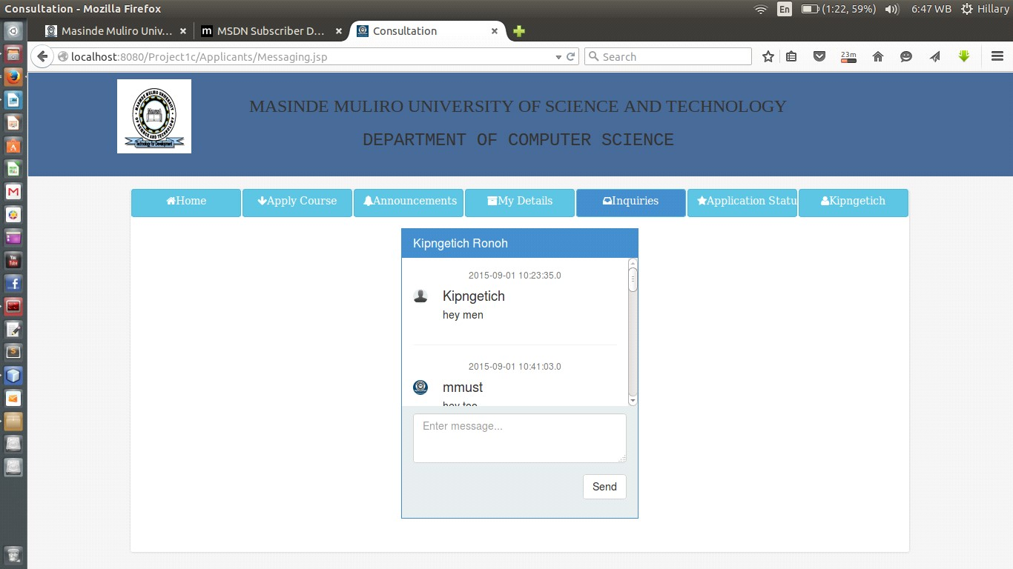

Figure 10: Screen Shot of Applicants’ inquiry area

#### 3.7.3.6 Application Status

This is where applicants receive the status about their application. When ranking has not been done, appropriate message will be shown, when it has been done, a message notifying applicants on their success or failure of their application is displayed.

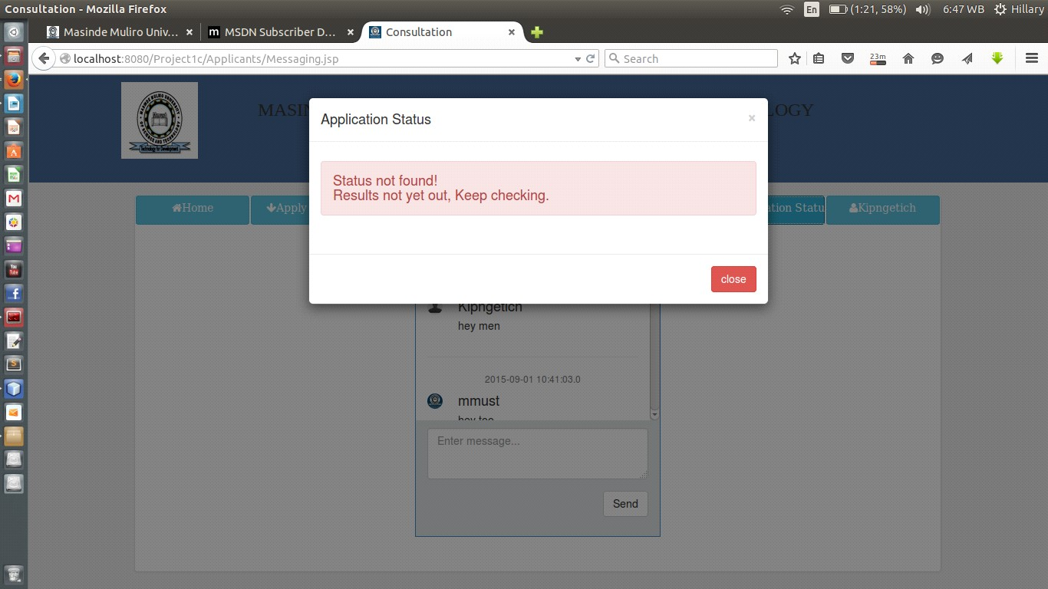

Figure 11: Screen Shot of Application Status dialog

### 3.7.4 Administrator Module

Administrator module form one of the core modules of the system. It is from this module that the admin is able to administer the system. It is composed of the following:

#### 3.7.4.1 Homepage

This is the admin dashboard, various statistical analysis are displayed on this page.

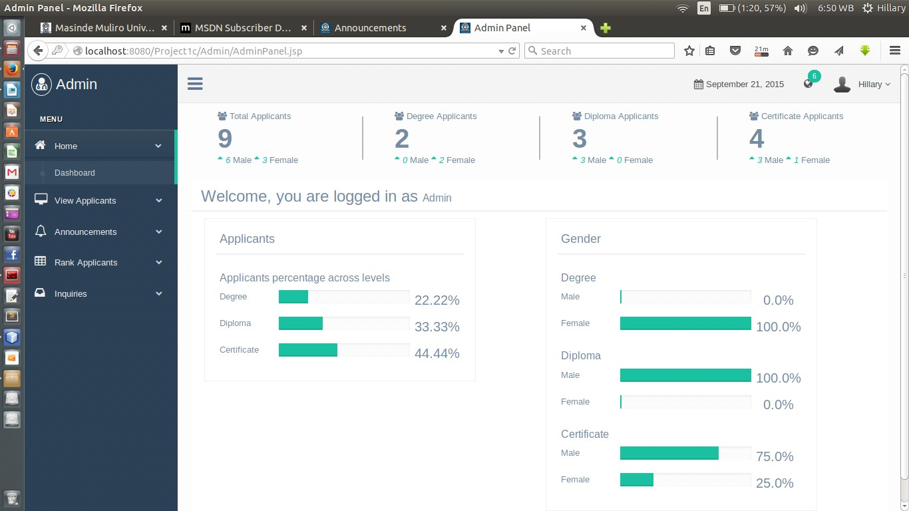

Figure 12: Screen Shot of Admin Homepage

##### 3.7.4.2 View Applicants

This is where the admin is able to view applicants from various course levels. The admin also is presented with the option to delete the applicant.

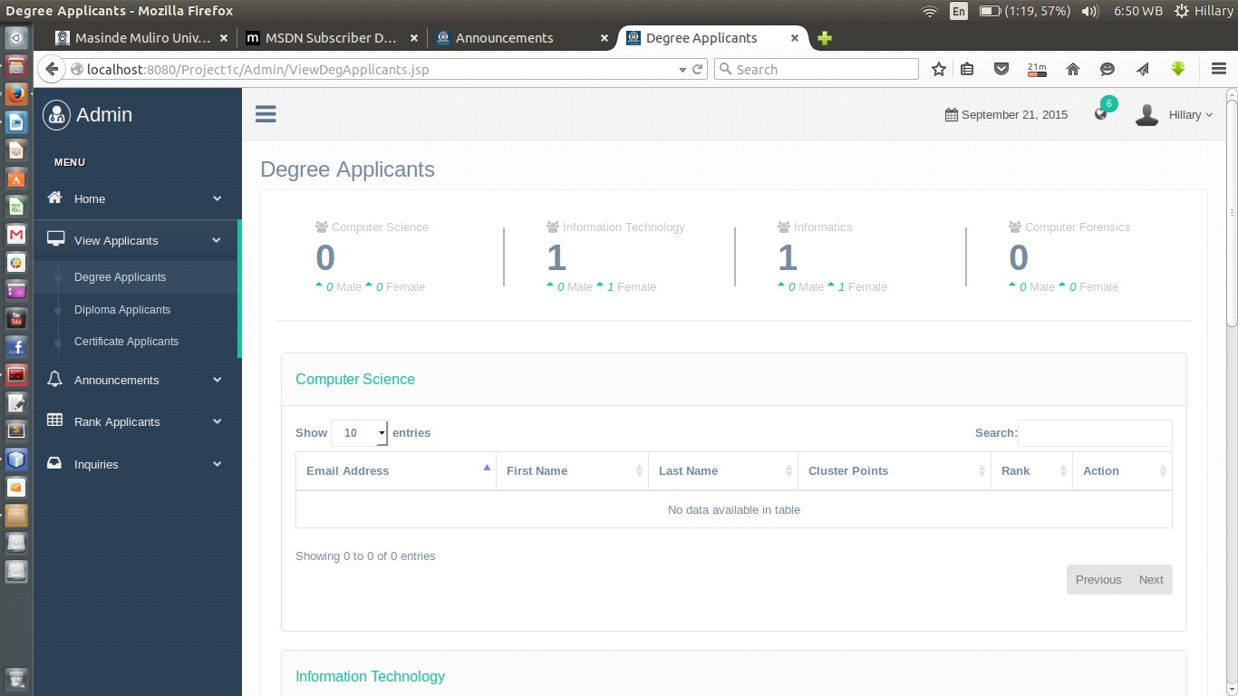

Figure 13: Screen Shot of Degree Applicants

**3.7.4.3 Post Announcements**

The admin posts announcements to applicants from this page.

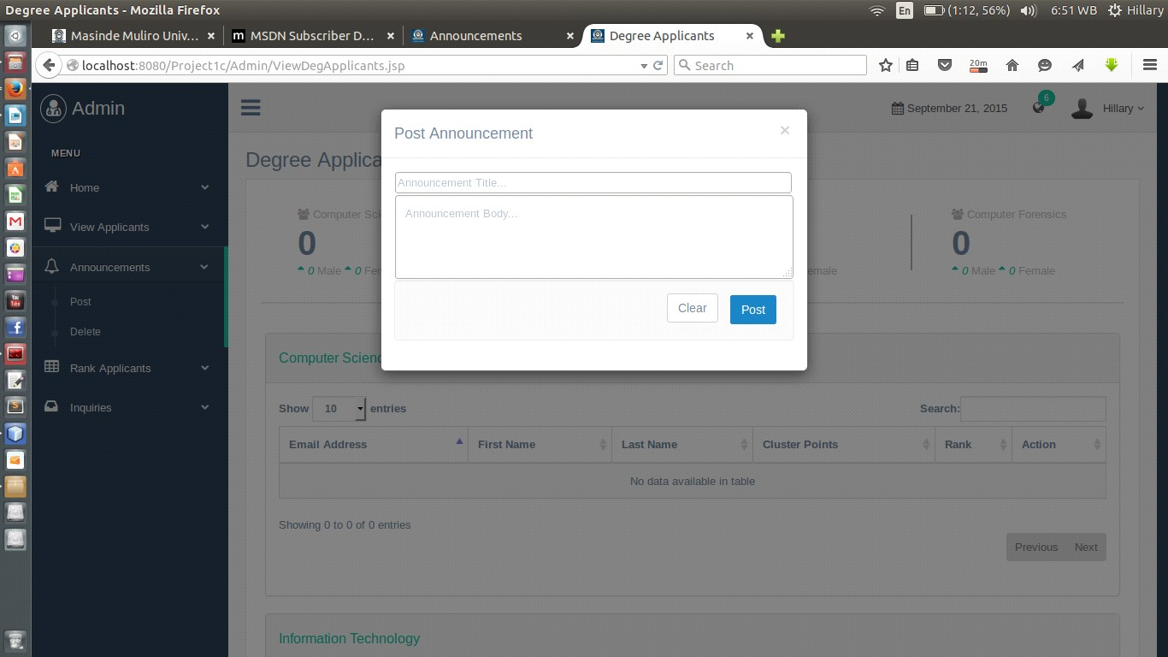

Figure 14: Screen Shot of Announcement posting modal

##### 3.7.4.4 Applicants Ranking

This is where the admin do the ranking of applicants on various course-levels based on the number required applicants.

Figure 15: Screen

Shot of Degree Applicants Ranking

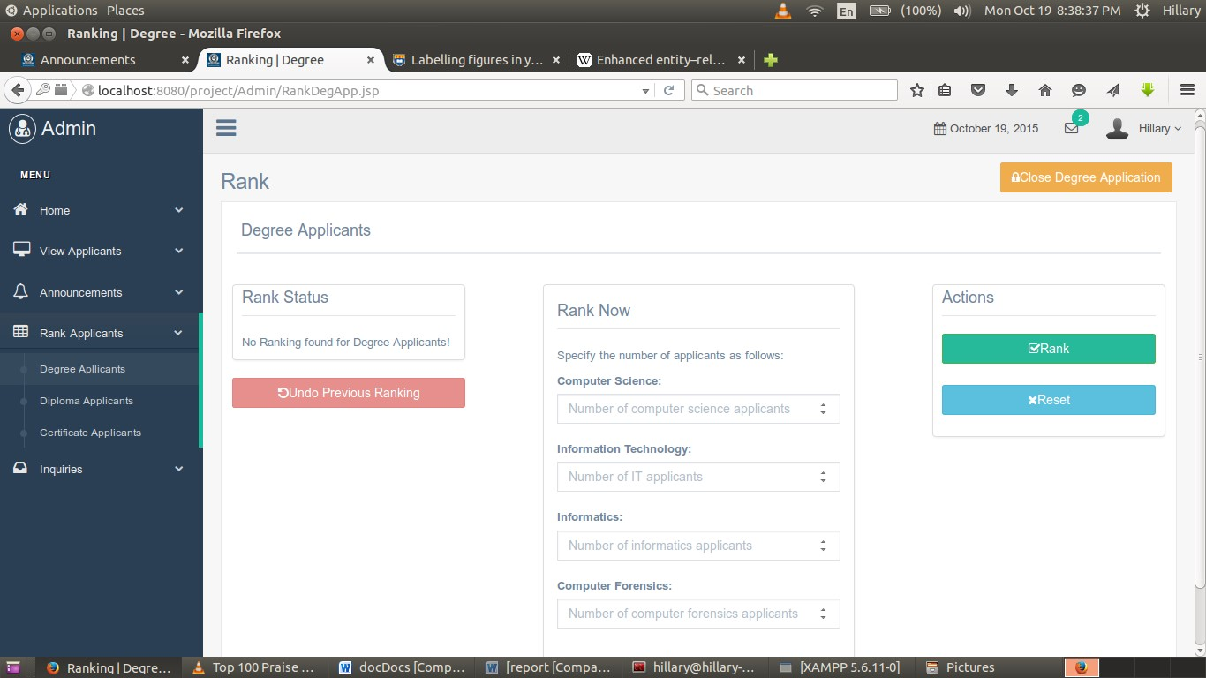

##### 3.7.4.5 Inquiries

Inquiries and chats from the applicants are answered from this section by the admin of the system.

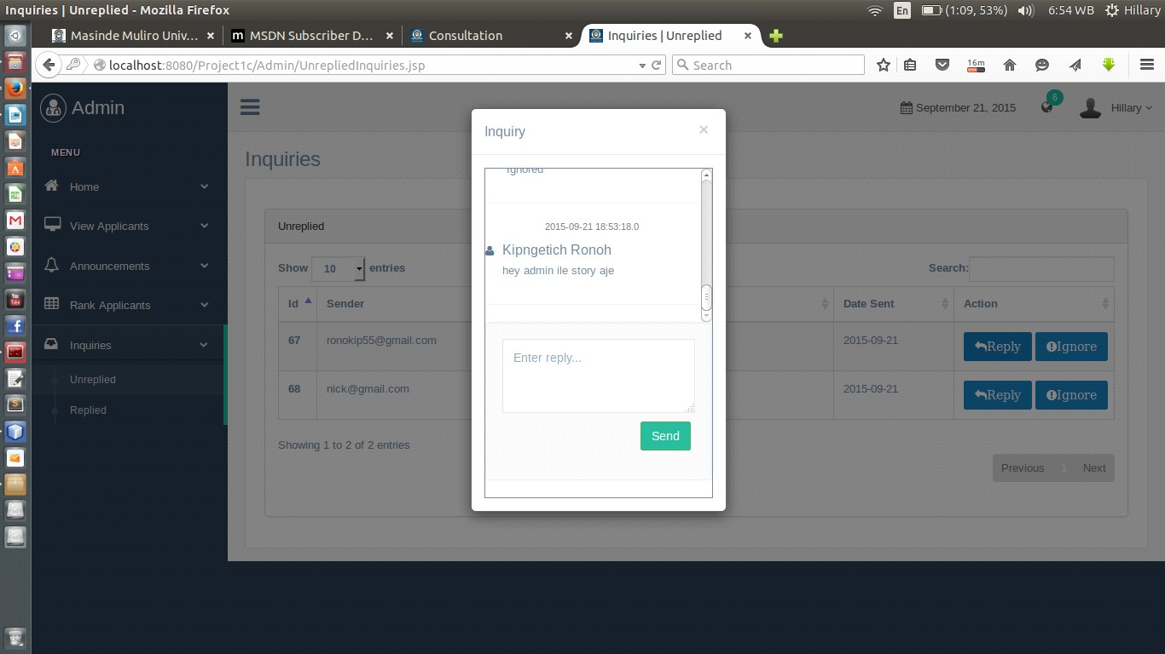

Figure 16: Screen Shot of Admin’s Inquiry area

# 4.0 CHAPTER 4

## 4.1 Implementation and Testing

The stage of implementation is the process of converting a system specification into an executable system. It involves coding, unit testing, module integration and testing, validation testing and documentation.

## 4.2 Coding

Coding was done using the following programming languages and platforms **Software:**

• Ubuntu 14.04 LTS operating system.

* Mysql database version 5.1.36.
* XamppServer 5.6.11
* JSP
* Apache tomcat version 7.0.64
* Netbeans IDE version 8.0.2
* Mozilla firefox version 40 **Hardware:**
* Intel Pentium 4 CPU with 2GB RAM and 2.2Ghz clock speed and 500GB hard disk.
* Modem

To ease the process of coding, the project was broken down into small modules so that each module could be developed, tested and integrated individually. Modularity enhances design clarity which in turn makes implementation easy as well as debugging, testing, documenting and maintenance of the software.

## 4.3 Unit Testing

Unit testing focuses on checking for validity of the smallest unit of software component or module. Using the component-level design description as a guide, important control paths were tested to uncover errors within the boundary of the module. The resultant system after the integration of the

modules was tested to ascertain its correctness in terms of input, processing and output. This was done by executing prepared test scenarios.

## 4.4 Module Integration and Testing

Integration testing is a systematic technique for developing a system while at the same time conducting tests to uncover errors associated with interfacing. The main aim is to take untested modules and build a program structure that has been dictated by design. Having written the codes for each module, the modules were integrated (combined) and the resulting main module was tested for conformity and completeness.

## 4.5 Validation Testing

The system was tested using prepared test cases to ascertain that the right system was built. It was also done to test if the system satisfied all the problem requirements of the project. The system was also given out to fellow students to work with and identify any faults in functionalities. During the process of validation, a number of test cases were carried out as described below.

### 4.5.1 Test Cases

A test case is prepared for each test that needs to be performed. The test cases result in the development of test reports, which is used for test-output analysis. The test cases provided are those of main modules of the system that covers system functionalities.

#### 4.5.1.1 Test Case 1

**Test Environment**: ACER LAPTOP 500GB HDD, 2GB RAM, Ubuntu 14.04 LTS, Apache tomcat Server, Mysql dbms.

**Software**: MMUST ONLINE-COURSE APPLICATION SYSTEM

**Module**: Applicant registration

**Test Id**: Test 1

**Test Name**: Registration

**Test Description**: This test registers an applicant into the system.

**Variables:** applicant names, email, and password.



Figure 17: User Registration

A user gets fully registered upon activation of their accounts via an email link sent to their emails.

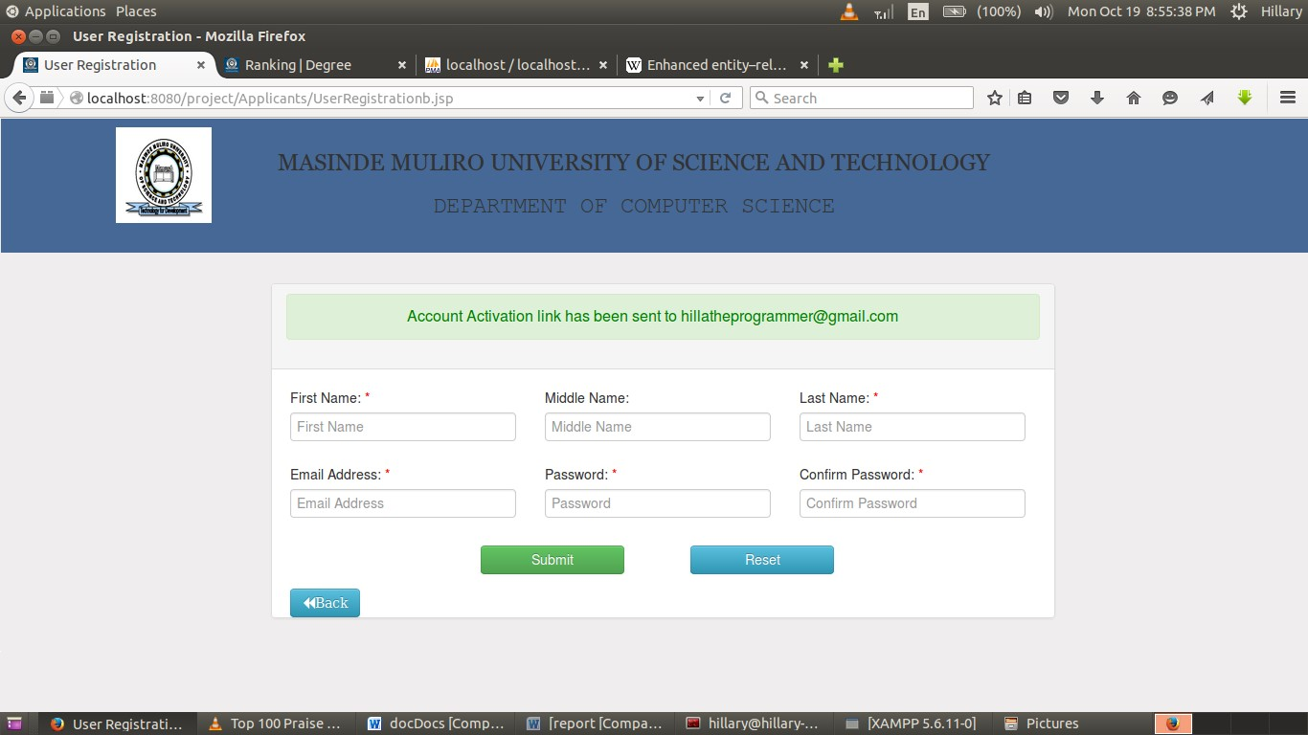

Figure 18: Successful Temporary Registration before account activation.

#### 4.5.1.2 Test Case 2

**Test Environment**: ACER LAPTOP 500GB HDD, 2GB RAM, Ubuntu 14.04 LTS, Apache tomcat Server, MySQL dbms

**Software**: MMUST ONLINE-COURSE APPLICATION SYSTEM

**Module**: Applicant Login

**Test Id**: Test 2

**Test Name**: Applicant authentication

**Test Description**: This test verifies the email and password to allow access to the system.

**Variables:** Email, password.



Figure 19: Login Entry Point

1. **Successful login:**

The user (applicant) will be taken to his/her account depending on user type.

1. **Unsuccessful login:**

The following DOM message will be shown to the user:

Wrong login credentials!!

In this state, a user will remain in the login window until he/she provides correct login details.

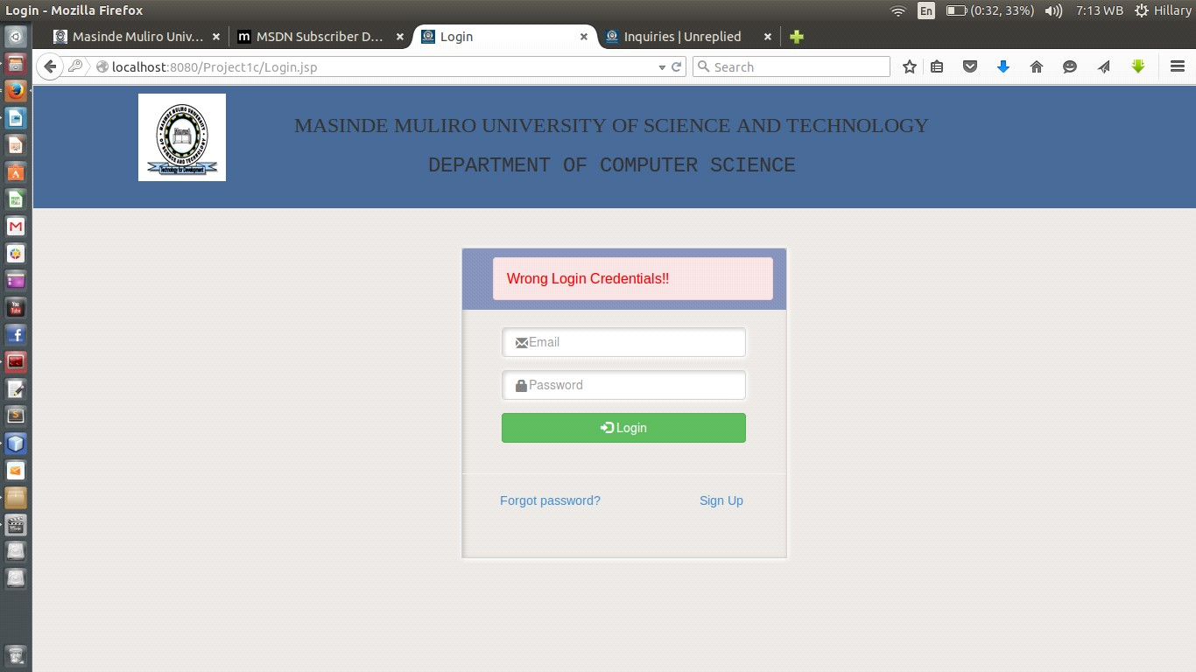

Figure 20: Unsuccessful Login Feedback

#### 4.5.1.3 Test Case 3

**Test Environment**: ACER LAPTOP 500GB HDD, 2GB RAM, Ubuntu 14.04 LTS, Apache tomcat Server, MySQL dbms

**Software**: MMUST ONLINE-COURSE APPLICATION SYSTEM

**Module**: Course application

**Test Id**: Test 3

**Test Name**: Course registration

**Test Description**: Allows an applicant to provide his/her personal details, his/her academic credentials, apply for a course (degree, diploma or certificate) then print the application form.

#### A. Section A: Personal Details

**Variables:** Applicant name (will be provided/already captured during registration), and other personal details (address, date of birth).

**On a Successful application,** a user will be notified as follows:

Details saved successfully…proceed to the next section.

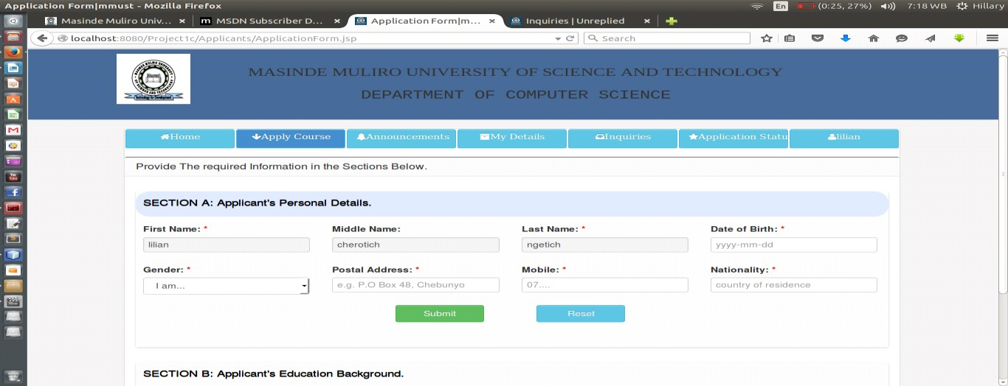

Figure 21

(

a): Personal details entry

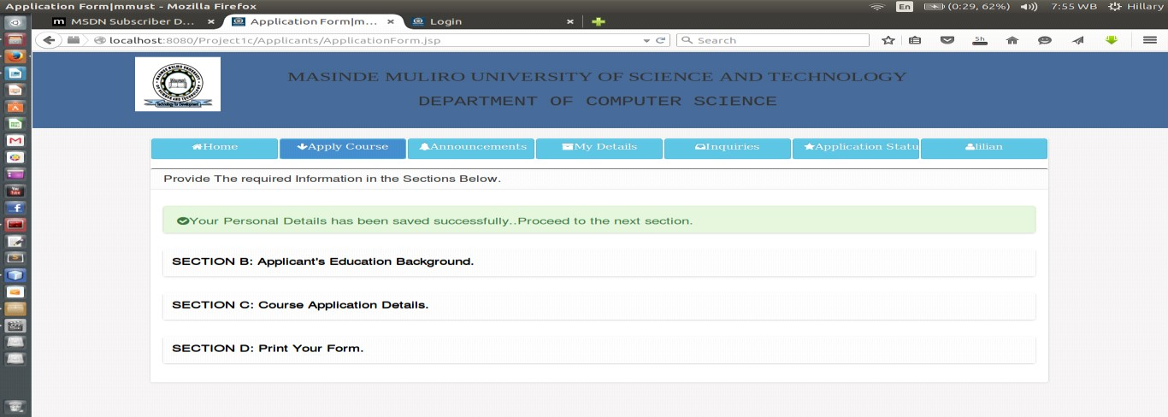

Figure 21(b): successful submission of personal details

#### B. Section B: Education Background

**Variables:** academic qualifications (kcse grades for 7 best performed subjects).

**On a Successful application,** a user will be notified as follows:

Details saved successfully…proceed to the next section.

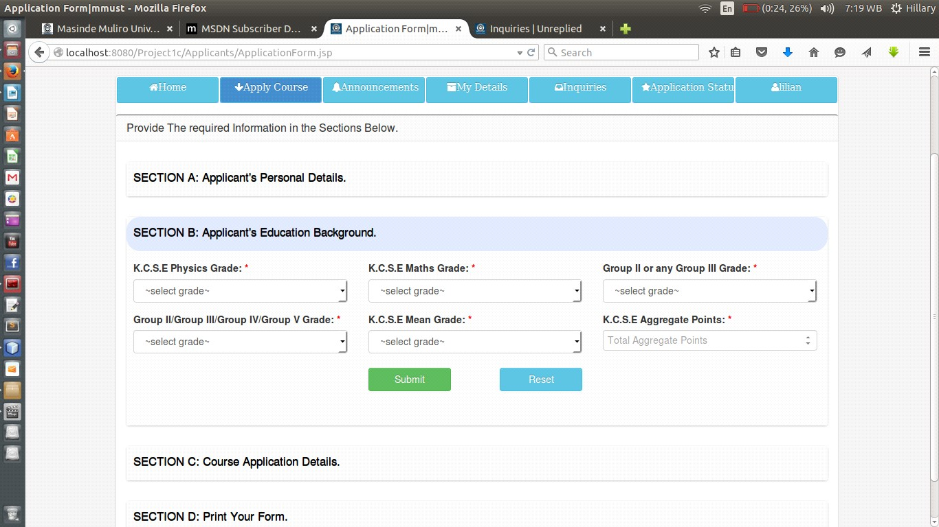

Figure 22

(

a): Education background details entry

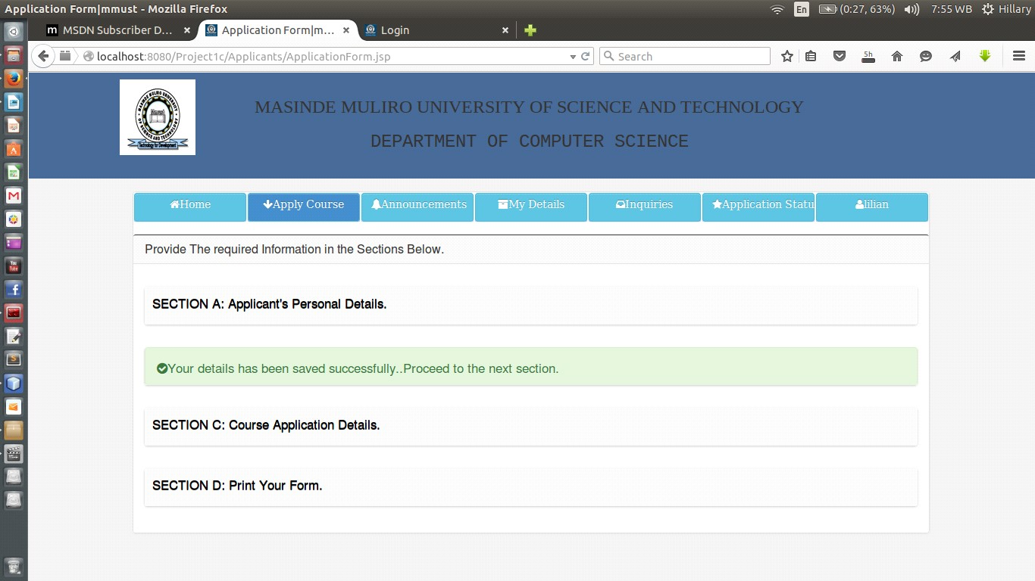

Figure 22(b): successful submission of academic details

#### C. Section C: Course Details

**Variables:** Course details (course level, course name) and campus details (branch name).

**On a Successful application,** a user will be notified as follows:

Details saved successfully…proceed to the next section.

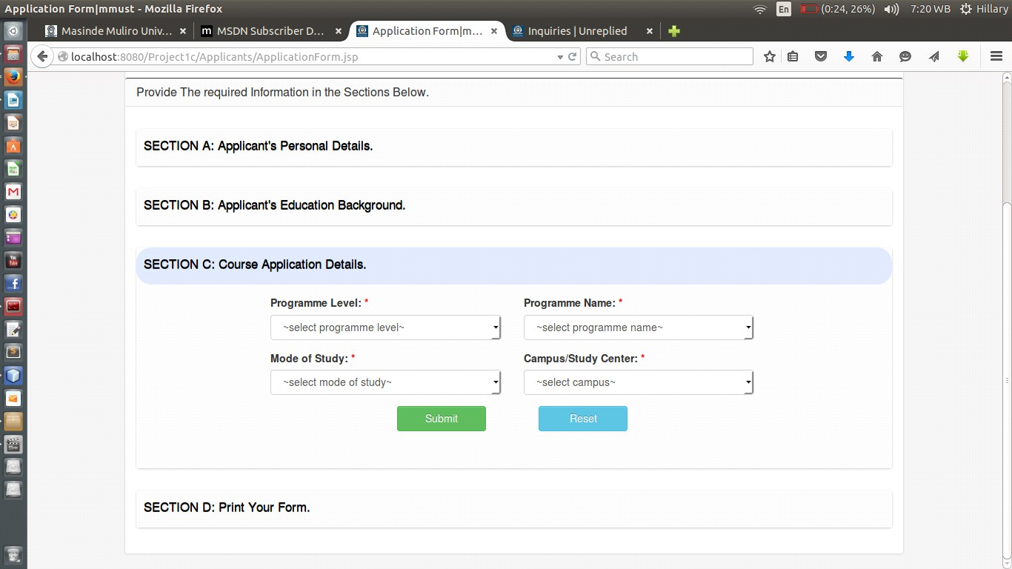

Figure 23

(

a): Course details entry

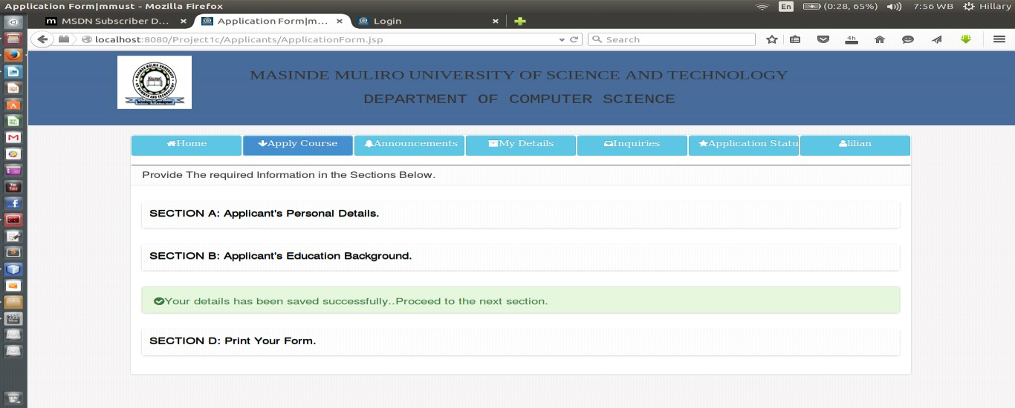

Figure 23(b): Successful submission of course details

#### D. Section D: Print Form

Once the applicants have filled all the three sections above, he can now print his form under this section.

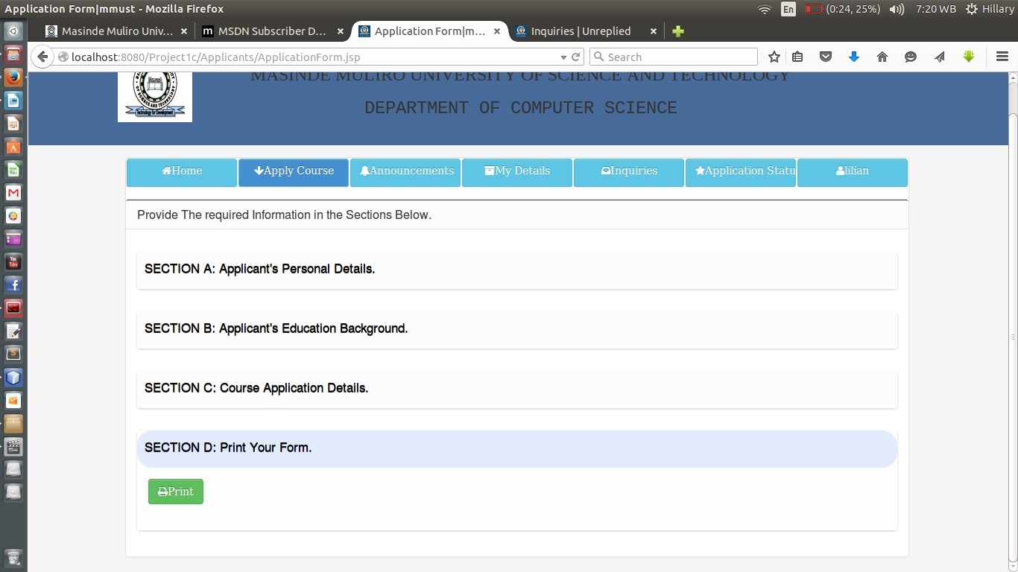

Figure 24

:

Form print

##### 4.5.1.4 Test Case 4

**Test Environment**: ACER LAPTOP 500GB HDD, 2GB RAM, Ubuntu 14.04 LTS, Apache tomcat Server, MySQL dbms

**Software**: MMUST ONLINE-COURSE APPLICATION SYSTEM

**Module**: Applicants ranking

**Test Id**: Test 4

**Test Name**: Applicants ranking

**Test Description**: Admin of the system doing the ranking of the applicants in the various course-levels (have to select the level).

**Variables:** Number of applicants required and based on the number of applicants that have applied.

**On Successful ranking,** the admin of the system will be notified as follows:

Ranking Successful

Figure 25(a)

:

Screen Shot of Diploma

Ranking

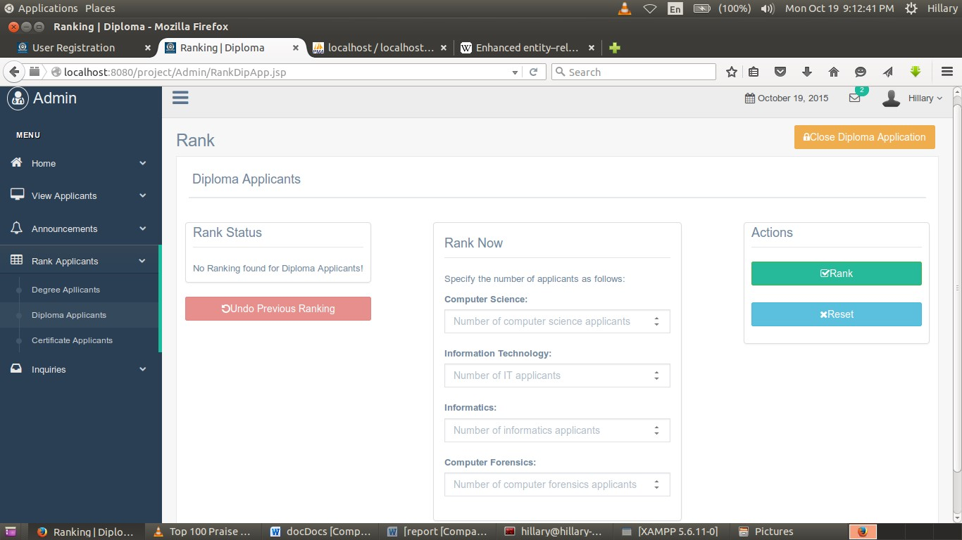

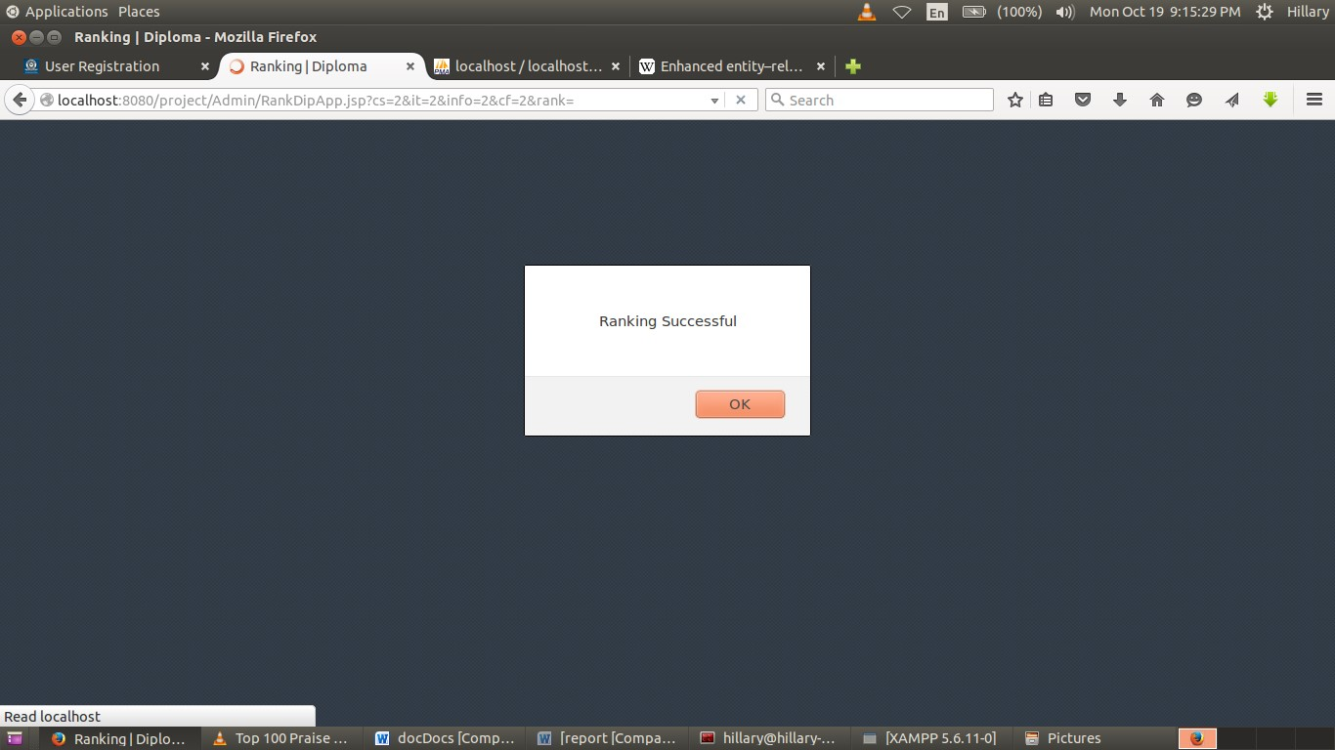

Figure 25(b): Successful Diploma Ranking

## 4.6 Configuration Review

A review of the system was carried out to ensure that all the elements of the software configuration were properly developed cataloged and had the necessary detail to support the maintenance phase of the software life cycle.

## 4.7 Security Testing

Security testing attempts to verify that protection mechanism built into the system will protect it from unauthorized access. This is done by the developer by deliberately inputting wrong usernames and passwords and check on the reaction of the system. Given enough time and resources, good security system will succumb to unauthorized accesses. The designer should then make it such that penetration cost more than the value of the information obtained through penetration

## 4.8 Actual Handover

The final version of the system was presented to the panel after satisfactorily testing it and removing the bugs.

# 5.0 CHAPTER 5

## 5.1 Summary and Achievements

The whole process of analyzing, designing and developing/implementing the information system project has been a fascinating experience. This is because it gave me a chance to apply useful knowledge and skills that had been acquired throughout my programme.

Therefore, the knowledge acquired throughout the system development was of great value in achieving the objectives of the project. Crucial units such as System analysis and design, Programming Concepts, Database Systems as well as IT Project Management proved to be the main source of knowledge and ability in realizing set goals.

The system developed catered for most of the user requirements that were gathered during the datagathering phase. The process of coming up with the system was very challenging and challenging at times. However with the assistance, help and moral support of fellow students, it was possible to overcome these challenges by taking necessary and fruitful solutions. Given the various circumstances, it can only be fair to assert that the system developed is reasonable and meets most of earlier projected objectives.

## 5.2 Constraints

The success of the project was constrained by the following factors 1. Inadequate time to collect all the information about all the records.

1. Limited reference materials.
2. Inadequate funds to undertake a thorough research on the problem domain.

## 5.3 Shortcomings

The system was based on information obtained from various stakeholders of MMUST which sometimes was difficult to find resource persons.

## 5.4 Discussion

This project has enabled me gain a vast experience and knowledge in IT field. It has made me go through a thorough integration of all the knowledge and skills I have acquired in the three years of my study.

To mention but a few, the system have enabled me put in practice Software development life cycle from requirements elicitation to documentation. It has also enabled me to interact and use the various CASE tools that are available to make the whole process easy and efficient. Among the tools that I have been able to interact with is MySQL Workbench which assist in database design, MySQL Database server, Apache tomcat web server and Adobe Dreamweaver CS5 which is one tool that has enabled me in designing good interfaces especially through its inbuilt CSS feature.

The project have also enabled me write proper software documentation and academic papers especially with the help of my supervisor who insisted on good documentation for an easy to maintain software.

The Project have also made me study bootstrap framework and JSP server site language both of which are not covered in the course syllabus and thus have enabled me go through a very intensive research and gain knowledge on various frameworks, languages, plugins and APIs.

## 5.5 Conclusion

The project in my view has been a success amidst a lot of challenges. Full Implementation of the system will pay tangible benefits to the Masinde Muliro University fraternity. It will make the university enjoys a competitive advantage among its counterparts since most of the universities have not implemented such a system.

## 5.6 Recommendations

This project is subject to improvement based on rising requirements. Even though the project was completed on the base of the requirement that were proposed, the system is very much open to improvement.

Masinde Muliro University should embrace and try to implement the systems made by student so that the knowledge body of MMUST can be greatly improved.

Funding of events geared towards solving problems of the society around the university should be harnessed which will improve the image of the university generally.

I would also like to recommend to the department to provide more guidance and materials about the methods of carrying out research and project report writing to students. This will go a long way in preparing students and enabling easy transition between project report writing, together with the rest of the deliverable items.

Finally students who have related projects should be assisted in the process of integrating them so that power of software’s developed locally can be harnessed.

## 5.7 Appendix

### 5.7.1 Project Schedule

Table 1: Project Schedule from week 1 to week 15

|  |  |  |  |  |  |  |  |  |  |  |  |  |  |  |  |  |  |
| --- | --- | --- | --- | --- | --- | --- | --- | --- | --- | --- | --- | --- | --- | --- | --- | --- | --- |
|  |  |  |  |  |  |  |  |  |  |  |  |  |  |  |  |  |  |
|  |  |  |  |  |  |  | ***DURATION IN WEEKS*** | | | | | |  |  |  |  |  |
|  |  |  |  |  |  |  |  |  |  |  |  |  |  |  |  |  |  |
|  |  |  | **1** | **2** | **3** | **4** | **5** | **6** | **7** | **8** | **9** | **10** | **11** | **12** | **13** | **14** | **15** |
| project identification | | |  |  |  |  |  |  |  |  |  |  |  |  |  |  |  |
|  |  |  |  |  |  |  |  |  |  |  |  |  |  |  |  |  |  |
| Feasibility study | | |  |  |  |  |  |  |  |  |  |  |  |  |  |  |  |
|  |  |  |  |  |  |  |  |  |  |  |  |  |  |  |  |  |  |
| Requirements capture and analysis | | |  |  |  |  |  |  |  |  |  |  |  |  |  |  |  |
|  |  |  |  |  |  |  |  |  |  |  |  |  |  |  |  |  |  |
| General system design | | |  |  |  |  |  | |  |  |  |  |  |  |  |  |  |
| ***Activity*** |  |  |  |  |  |  |  |  |  |  |  |  |  |  |  |  |  |
| User interface design | | |  |  |  |  |  |  |  | |  |  |  |  |  |  |  |
|  |  |  |  |  |  |  |  |  |  |  |  |  |  |  |  |  |  |
| System coding | | |  |  |  |  |  |  |  |  |  | |  |  |  |  |  |
|  |  |  |  |  |  |  |  |  |  |  |  |  |  |  |  |  |  |
| Module integration and testing | | |  |  |  |  |  |  |  |  |  |  |  |  |  |  |  |
|  |  |  |  |  |  |  |  |  |  |  |  |  |  |  |  |  |  |
| Implementation | | |  |  |  |  |  |  |  |  |  |  |  |  |  |  |  |
|  |  |  |  |  |  |  |  |  |  |  |  |  |  |  |  |  |  |
| System handover | | |  |  |  |  |  |  |  |  |  |  |  |  |  |  |  |
|  | | |  |  |  |  |  |  |  |  |  |  |  |  |  |  |  |
|  | Documentation | |  |  |  |  |  | | | | | |  |  |  |  |  |

### 5.7.2 Budget

Table 2: Project Budget

|  |  |  |
| --- | --- | --- |
| **Item** | **Quantity** | **Amount (ksh)** |
| Standard Personal Computer system | 1 | 25,000 |
| Software |  | 2,000 |
| External storage disk | 1 | 800 |
| Stationaries |  | 500 |
| Printing, photocopying, binding and printer |  | 4,000 |
| Internet connection facilitation(modem) |  | 3,000 |
| Miscellaneous |  | 2,000 |
| **Total** |  | **37,300** |

## 5.8 References

* Gerti Kappel et.al (2003): Web Engineering. *John Wiley &Sons Ltd*
* Mark Maslakowski (2000): Sam's Teach Yourself Mysql in 21 Days. *Sams Publishing*
* [www.w3schools.com/bootstrap/bootstrap_navbar.asp](http://www.w3schools.com/bootstrap/bootstrap_navbar.asp)
* https://github.com/bbottema/simple-java-mail

1. .8 Purpose of the Project ...................................................................................................................... 4
2. .9 Objectives of the Project ................................................................................................................... 4
3. .10 Project Justification ........................................................................................................................... 4
4. .11 Requirements Specification .............................................................................................................. 5
5. .11.1 Functional Requirements .................................................................................................................. 5
6. .11.2 Non Functional Requirements .......................................................................................................... 5
7. .12 Materials Required............................................................................................................................ 6
8. .12.1 Software Requirement ...................................................................................................................... 6
9. .12.2 Hardware Requirement .................................................................................................................... 6
10. .12.3 Others ................................................................................................................................................ 6
11. .0 CHAPTER 2......................................................................................................................................... 7
12. .1 Literature Review .............................................................................................................................. 7
13. .0 CHAPTER 3......................................................................................................................................... 9
14. .1 Design and Methodology .................................................................................................................. 9
15. .2 General Overview ............................................................................................................................. 9
16. .3 Design Methodology ....................................................................................................................... 10